Lesson 1: The Water Cycle Name:__________________

Three States of Matter

Directions: What are the three states of matter? Look at each image and label the matter a solid, liquid, or gas.

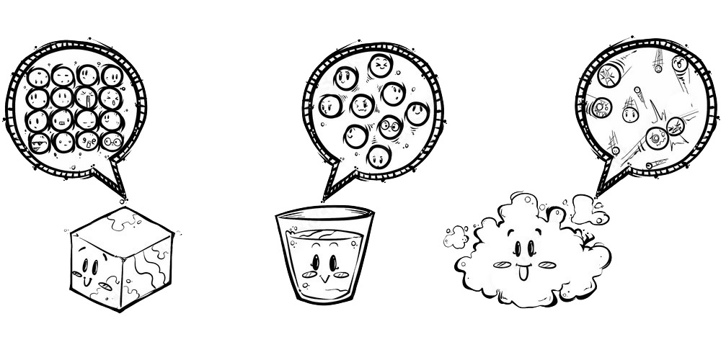

1._______________ 2.__________________ 3.__________________

